**Answer -001**



**Answer -002**



**Answer -003**



More about problem 3

Alpha-ketol rearrangementinvolves the transformation of an alkoxide into a carbonyl group with concomitant movement of the bonding electrons of the migrating group towards an adjacent trigonal center. A distinctive feature of this particular rearrangement, however, is its reversibility—as a result, the more stable α-hydroxy carbonyl compound is favored. A general scheme for the rearrangement is shown below.

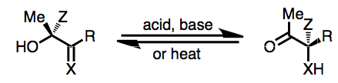

For more information, see:

