Zhou Group Mechanism Problems-20161023
Answer -001

Answer -002
Favorskii Rearrangement
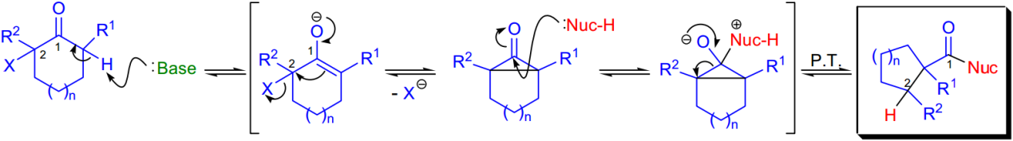
Homo-Favorskii Rearrangement

Answer -003

