09/12/2022 Rui Wang

Problem-001

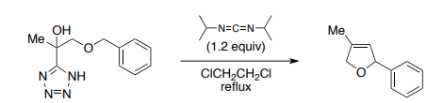

Ref: D. J. Wardrop et al., Org. Lett., 2012, 14, 1548

Problem-002

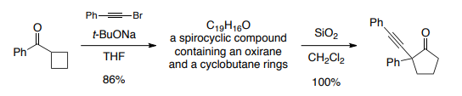
Ref: V. Gevorgyan et al., J. Am. Chem. Soc., 2008, 130, 13538

