**05/12/2024 YeDan**

**Problem-001**



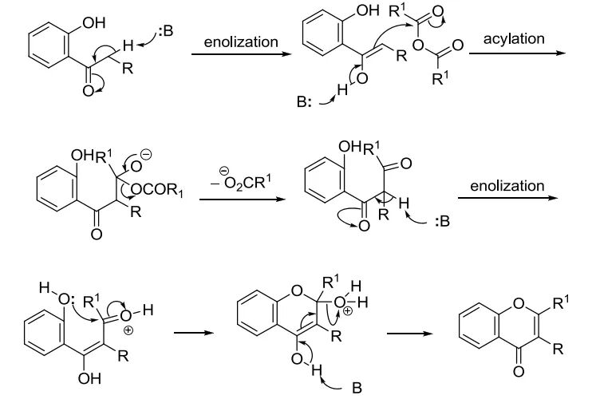

**Problem-002**



