**09/22/2024 YeDan**

**Problem-001**

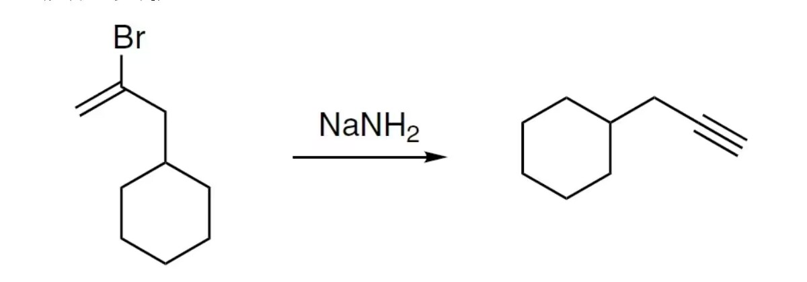

**Problem-002**

