**02/17/2025 YeDan**

**Problem-001**



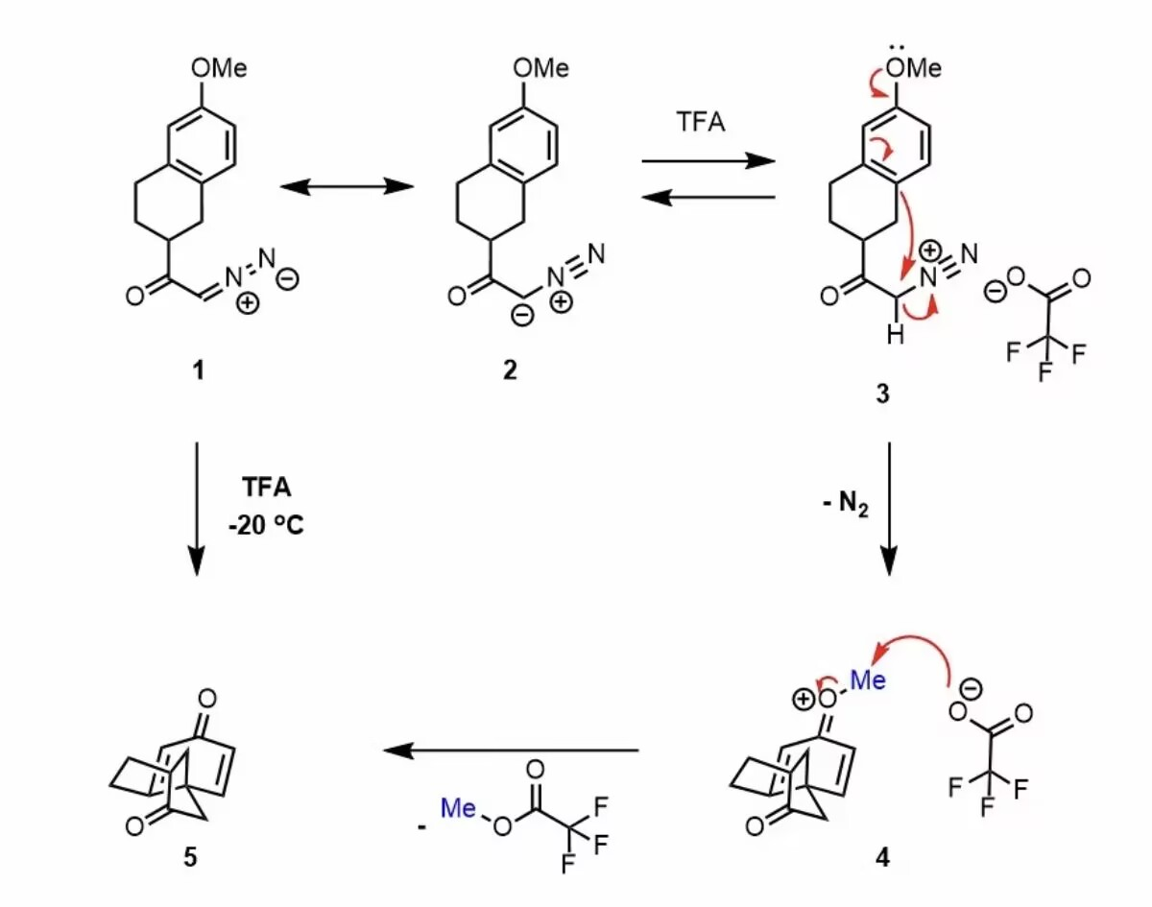

**Problem-002**



