03/07/2021 Xia Li
Answer-001

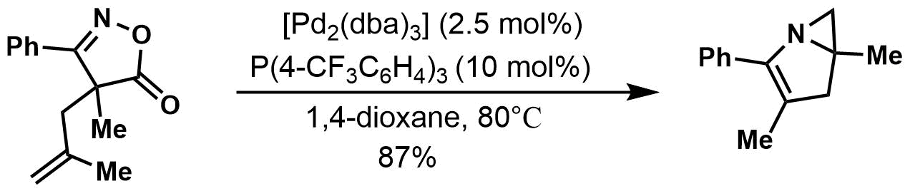
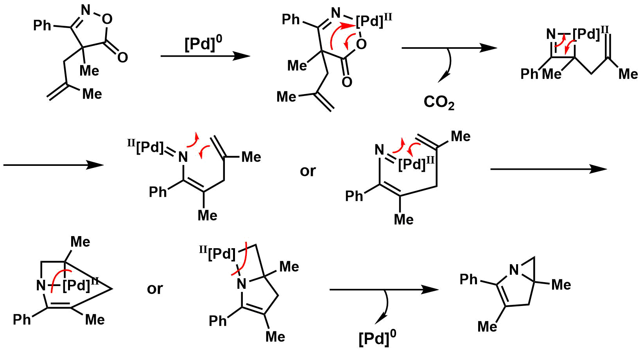

K. Ohe et al. Angew. Chem. Int. Ed., 50, 11470 (2011)

Answer-002

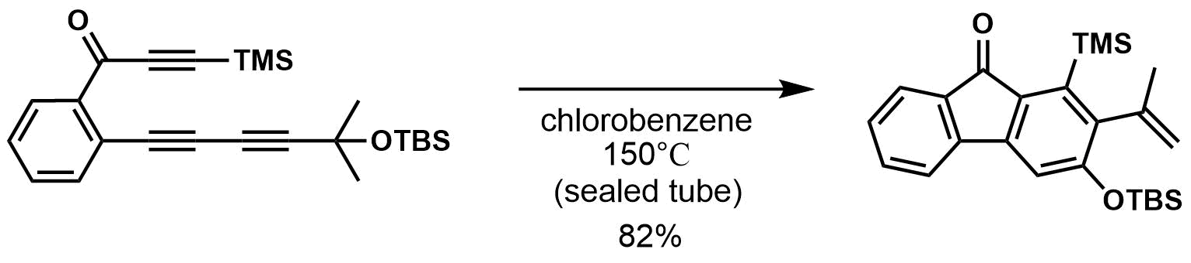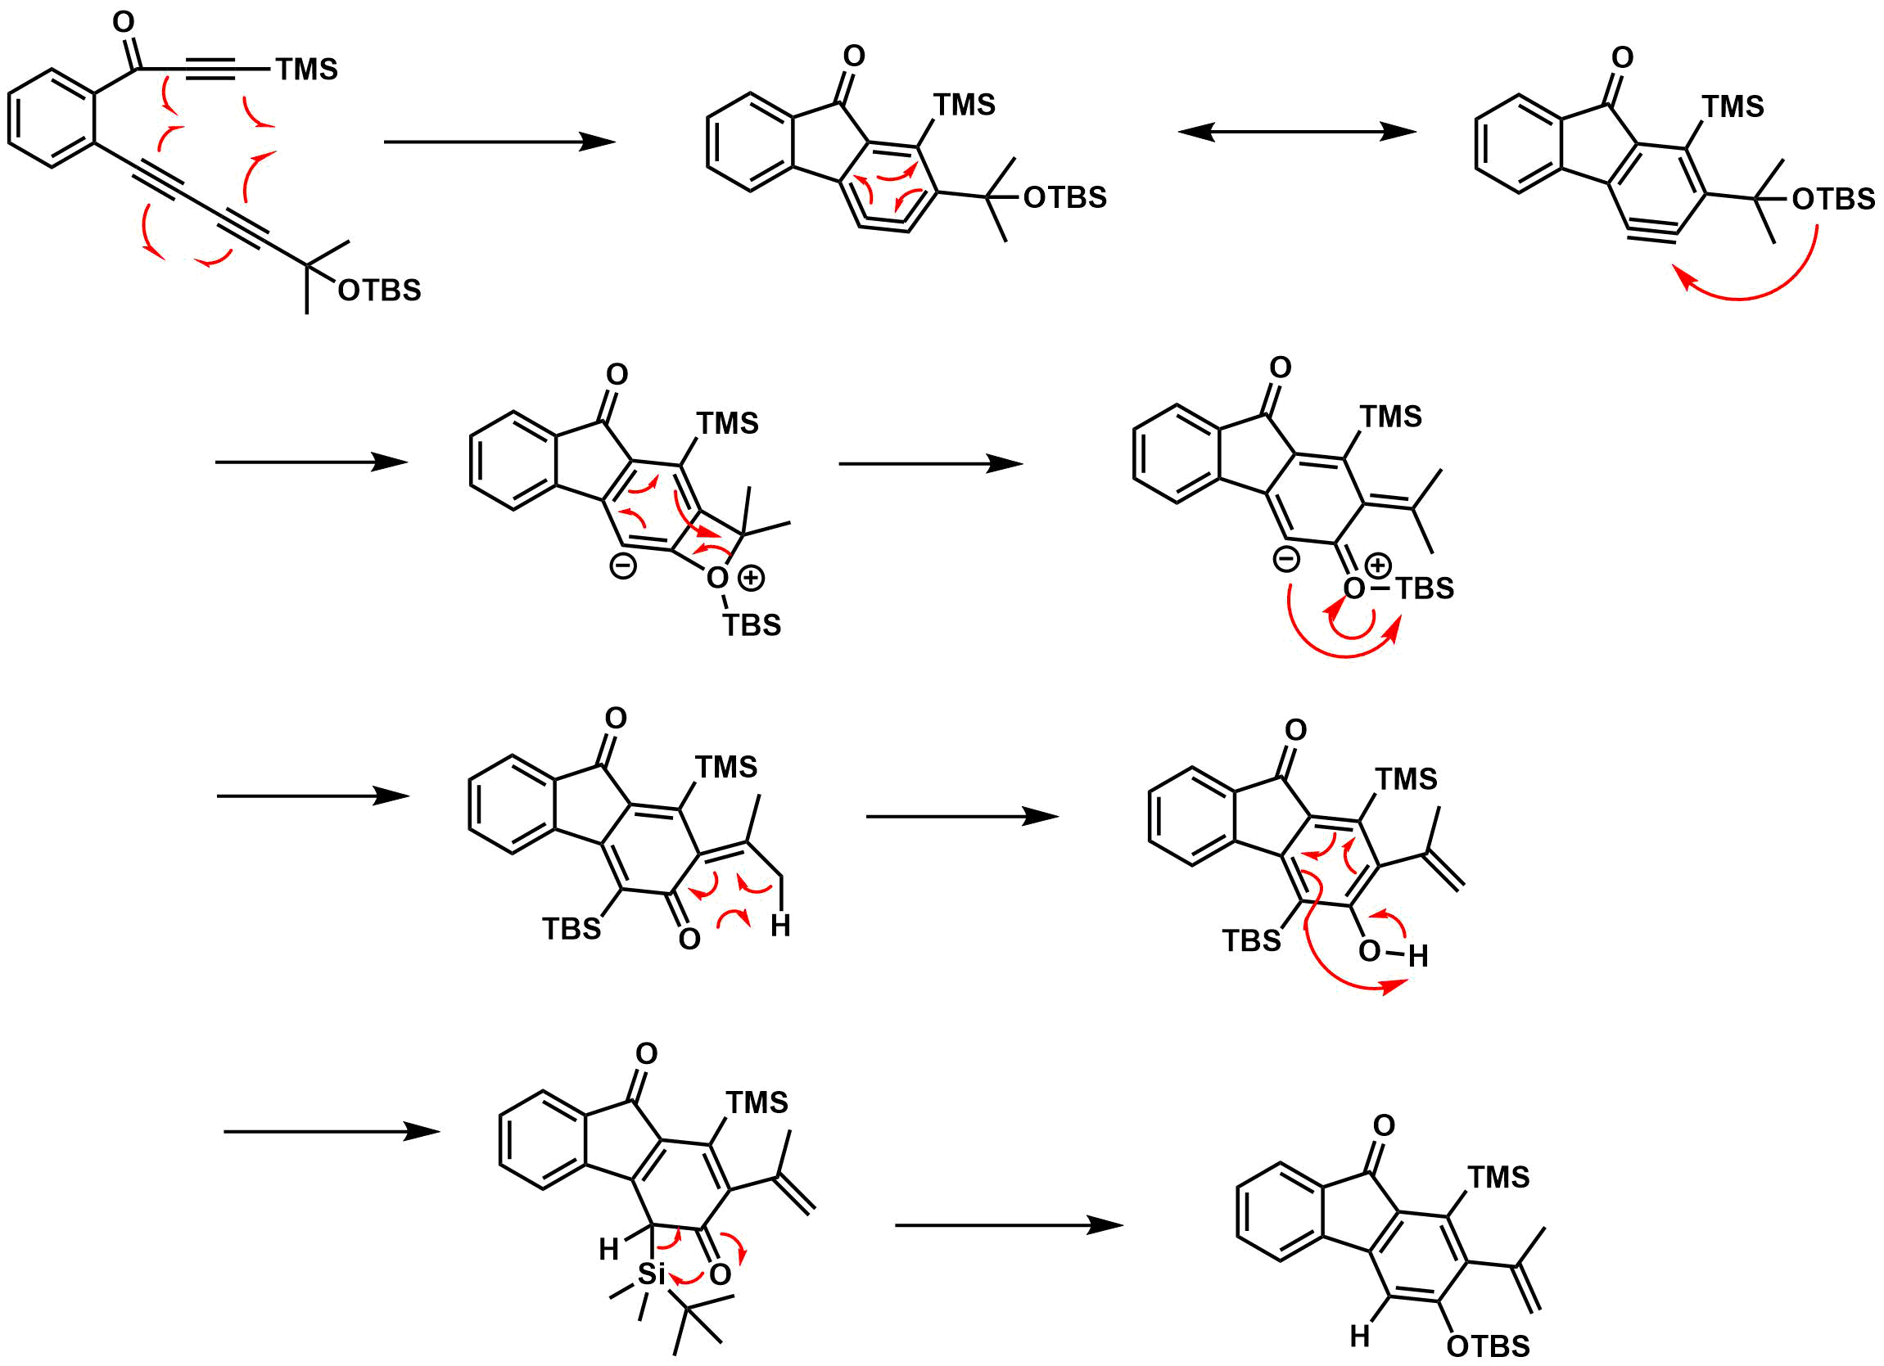

T. R. Hoye et al. Org. Lett., 21, 1672 (2019)

