03/01/2021 Xia Li
Problem-001

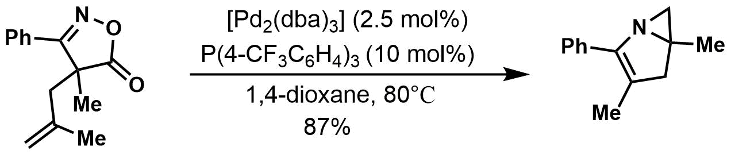

Problem-002
