Zhou Group Machanism Problems-20161030
Problem -001
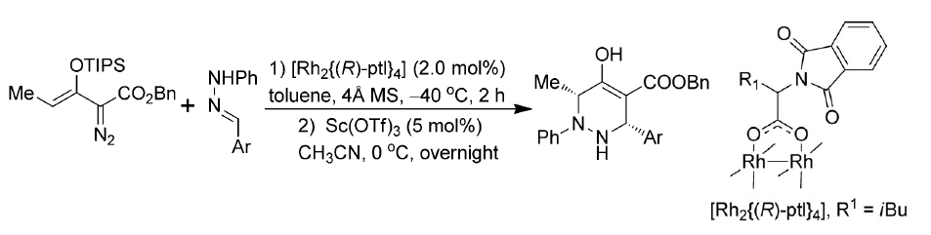
Michael P. Doyle, DOI: 10.1002/anie.201203962.
(Hint:本反应涉及Rh catalyzed vinylogus N-H insertion, Sc-catalyzed Mannich addition)

Problem -002
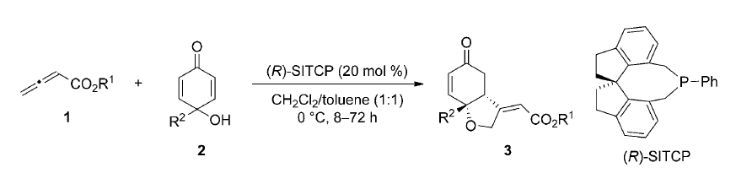
Hiroaki Sasai, DOI: 10.1002/anie.201508022
（Hint:该反应涉及β, γ-umpolung of allenic esters）

