**07/16/2023 Zhongliu Sun**

**Problem-001**

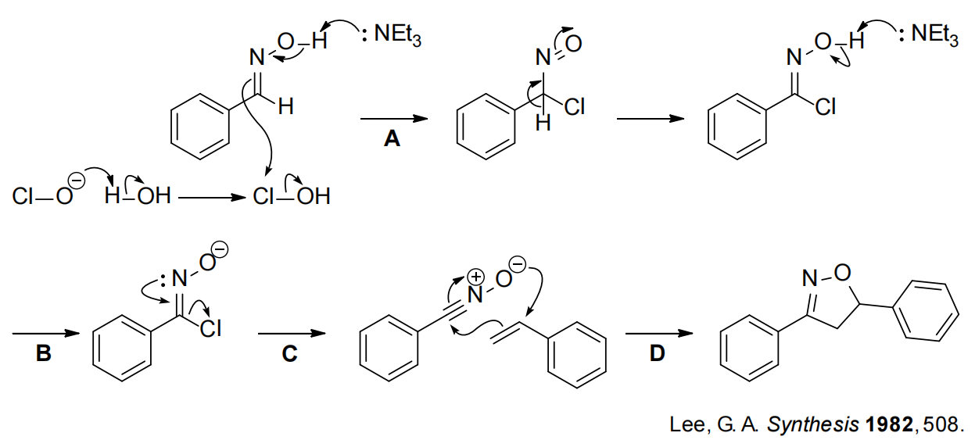

**Problem-002**

