**12/08/2024 Zhongliu Sun**

**Problem-001**



Ref: *J. Org. Chem.*, 1**998**, *63*.7594

**Problem-002**



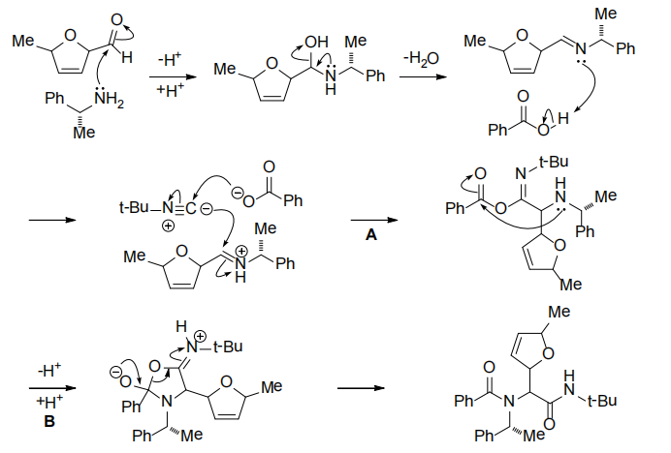

Ref: *J. Am. Chem. Soc*, **1980**, *102*, 7505