9/22/2024 Dongkai Wang
Problem-001
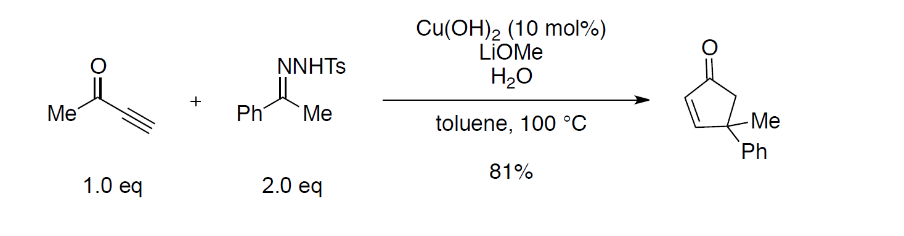
Problem-002
